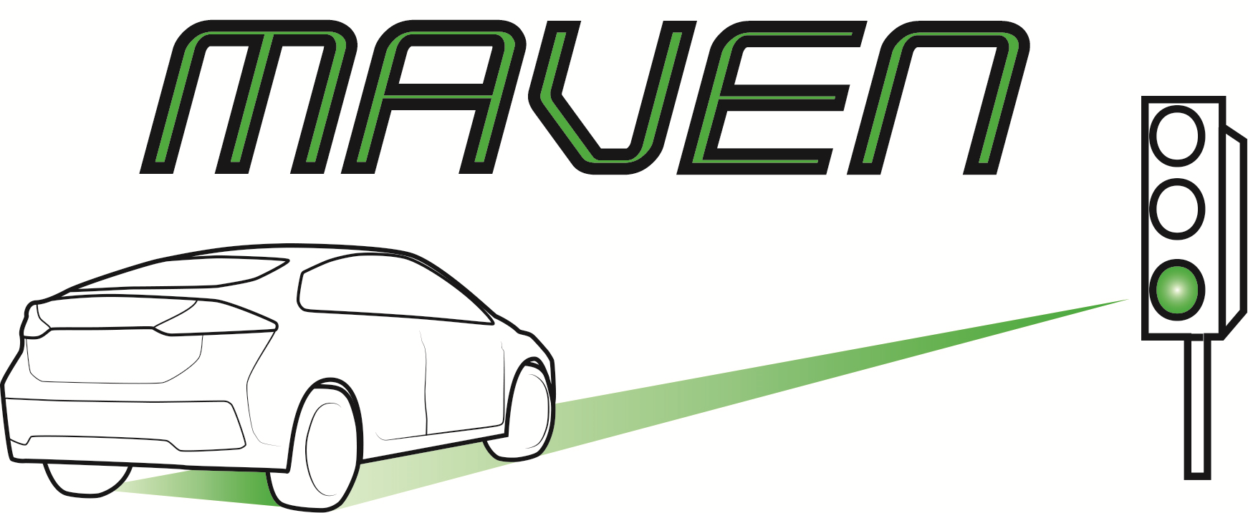
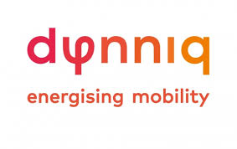

PRESS RELEASE

Self-driving cars a step closer in cities
Results from European MAVEN project prove the benefits of autonomous vehicles

Eindhoven, 6 June 2019 – Dynniq presented results from the European MAVEN project during today's ITS European Congress 2019 in Eindhoven. The conclusions prove that the expected benefits of autonomous vehicles, when it comes to safety, traffic flow and sustainability, can actually be realised. The obstacles for introducing self-driving vehicles in urban environments have thus been reduced.

Improving safety and efficiency in traffic
Dynniq is the project coordinator for a European consortium that spent the past 3 years working on the project - thanks to subsidies from the Horizon 2020 Research and Innovation Framework Programme - under assignment from the European Commission. Robbin Blokpoel from Dynniq: “Our aim was to make traffic flow safer and more efficient by using new possibilities offered by autonomous vehicles. There are still question marks about whether autonomous vehicles could cause extra problems in cities. However, by improving communication between individual vehicles and between vehicles and the roadside, obstacles for safely and efficiently integrating self-driving cars into urban traffic have now been eliminated.”

Symbiosis between traffic management and autonomous vehicles
Intersections can be used a lot more efficiently by creating symbiosis between vehicles and infrastructure. When approaching an intersection, vehicles are offered advice about their speed and driving lane, so they can pass the intersection without having to stop. The vehicle then returns information about whether the advice has been followed, and the traffic lights use this info to control flow at the intersection. Blokpoel: “Our system has been successfully tested in real traffic situations on several occasions, including in Helmond.”

An effective green wave and 15% reduction in CO2 emissions
Besides tests in real-life traffic situations, the MAVEN project also involved simulations that investigated impact on the city as a whole. The following results were achieved when all vehicles were autonomous: average queuing time was reduced by 39% by splitting traffic into bunches. Symbiosis between traffic lights and vehicles reduced lost time by 27%. A green wave can be created if the system is used over several intersections, which is a lot more effective than a traditional green wave because vehicles communicate with each other. In this case, average waiting times are reduced by 73%, lost time is reduced by 47% and CO₂ emissions are reduced by 15%.

Accelerated introduction of self-driving vehicles
“The faster that self-driving vehicles are introduced, the sooner we can reap the benefits”, says Blokpoel. “We have also developed a roadmap for the introduction of automated traffic. This will help road authorities to understand future changes in their role and their traffic management activities. As far as industry is concerned, a framework is now available for developing software that is needed to quickly take the next step.”

About Dynniq
Dynniq is a technology services provider that offers integrated solutions in the field of Parking, Energy and Mobility. The company designs, develops and maintains high-grade technological solutions, like intelligent parking solutions, flow-related traffic systems and energy solutions based on, for example, solar energy or direct current. Dynniq employs over 1800 people and is active in the European market, but also in South America, the United States and Canada.

